# Algorithm

Problem: New Patient Information

Input: Patient details

Output: New patient record

Procedure

1. Ask if the patient is already registered

1.a. If yes, verify identity

1.b. If no, register patient

2. Inquire reason for visit

3. Has an appointment?

3.a. If yes, verify appointment slip

i. Verification successful. Proceed to step 4.

ii. Verification failed. Proceed to 3.b

3.b. If no, schedule an appointment

i. Go to scheduled appointment date

4. Go to the physician

5. Clinical Assessment

6. Undergoing treatment?

6.a. If yes, go to the admission office. A nurse would be

available to assist you shortly

6.b. If no, go to the billing department

7. Pay the hospital fees

8. End

# 

# Pseudocode

Problem: New Patient Information

Input: Patient details

Output: New patient record

BEGIN

SYSTEM PRINTS: “Welcome to XX Hospital!”;

SYSTEM PRINTS: “Are you already registered?”;

SYSTEM COLLECTS input from user;

IF menu option is YES THEN (success=1; fail=0):

SYSTEM CHECKS for existing records;

IF RECORD EXISTS THEN

SYSTEM PRINTS: “Record exists.”;

SYSTEM RETURNS 1;

ELSE

SYSTEM PRINTS: “No records found.

Please register.”;

SYSTEM RETURNS 0;

ENDIF

ELSE IF menu option is NO or SYSTEM RETURNS 0

SYSTEM ASKS for patient information;

IF SUCCESS

SYSTEM PRINTS: “Patient Registered!”;

ELSE

SYSTEM PRINTS: “Registration failed. Please try

again or go to helpdesk”.

ENDIF

ENDIF

SYSTEM PRINTS: “Reason for visit?”;

SYSTEM COLLECTS input from user;

SYSTEM PRINTS: “Has an appointment?”;

SYSTEM COLLECTS input from user;

IF menu option is YES THEN (success=1; fail=0):

SYSTEM VERIFIES appointment;

IF verification is successful THEN

SYSTEM PRINTS: “Please go to your physician.”;

RETURN 1;

ELSE

SYSTEM PRINTS: “No records found.

Please schedule an appointment.”;

RETURN 0;

ENDIF

ELSE IF menu option is NO or SYSTEM RETURNS 0 THEN:

SYSTEM PROCESSES appointment;

SYSTEM PRINTS “Go to the scheduled appointment date.

Thank you.”;

END MODULE;

ENDIF

SYSTEM PRINTS: “Undergoing treatment?”;

SYSTEM COLLECTS input from user;

IF menu option is YES THEN

SYSTEM PRINTS “Go to the admission office.  
 Thank you.”;

END MODULE;

ELSE

SYSTEM PRINTS “Go to the billing station”;

ENDIF

SYSTEM PRINTS: “Are hospital bills paid?”;

SYSTEM COLLECTS input from user;

DO LOOP

IF menu option is YES THEN (success=1; fail=0)

SYSTEM VERIFIES Payment;

IF verification is successful THEN

SYSTEM PRINTS: “Thank you for your payment.”;

RETURN 1;

ELSE

SYSTEM PRINTS: “No payment found. Please pay

your bills or go to helpdesk.”;

RETURN 0;

ENDIF

ELSE IF menu option is NO or SYSTEM RETURNS 0 THEN

SYSTEM PRINTS “Please pay your hospital bills”;

Return 0;

WHILE RETURN !==1;

END

# Flowchart

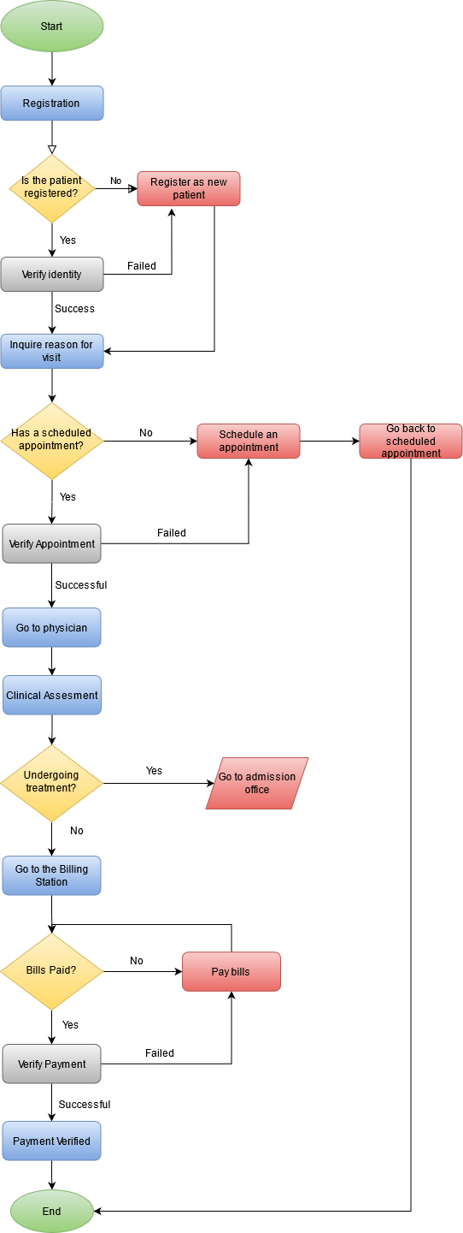

**LEGEND (Enlarge image if needed)**

* Ellipse, Green - START and END of process
* Rectangle, Blue - Process
* Rectangle, Red - Process requiring user input/helpdesk
* Diamond, Yellow - Decision
* Parallelogram, Red - Process outside the scope of REGISTRATION
* Rectangle, black - verification

**Created by: MG BAYBAY**